You are receiving this email as a member of the media.
If you wish to unsubscribe from future messages, please reply with UNSUBSCRIBE in the subject line.

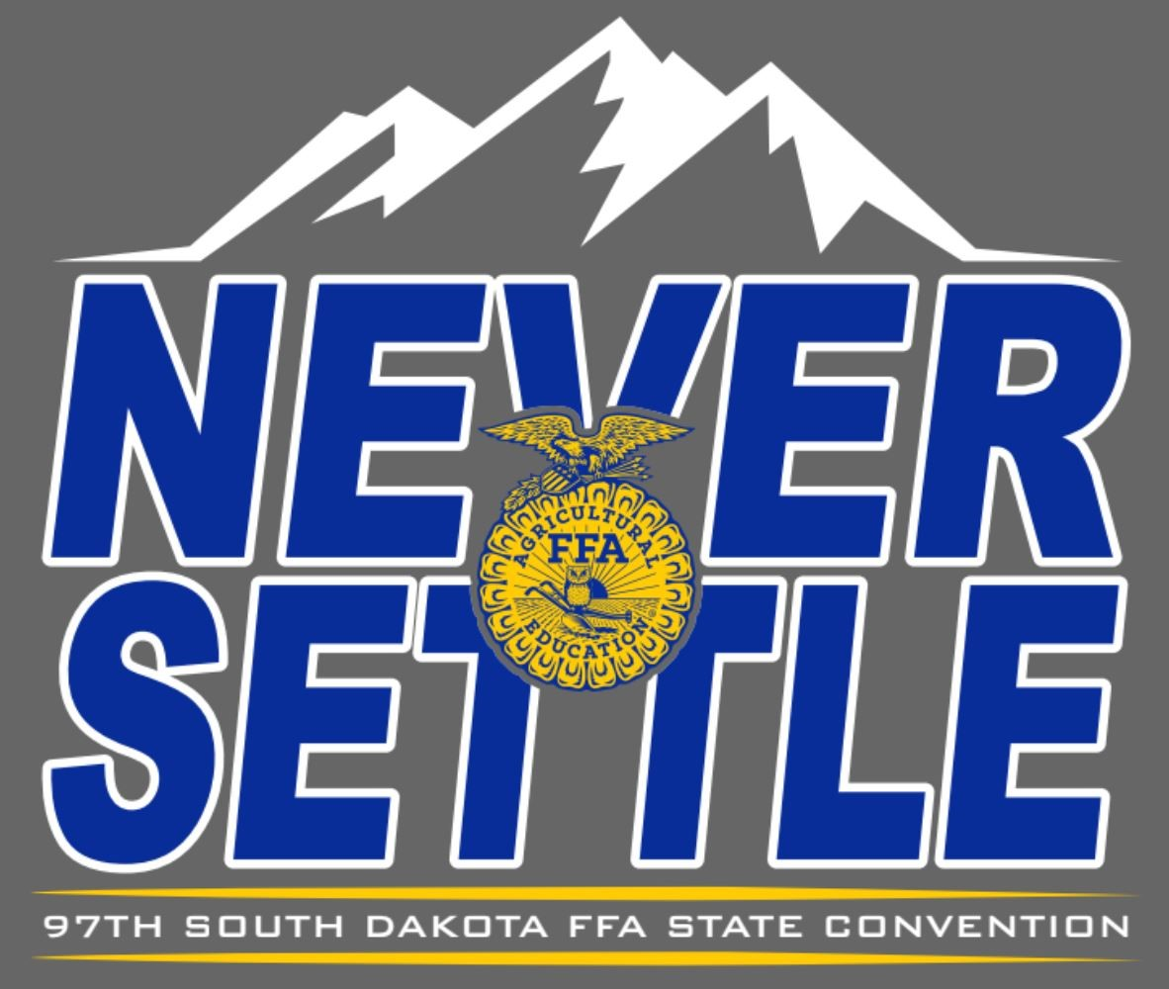
NEWS RELEASE

South Dakota FFA Association

Website: www.sdaged.org
Facebook: www.facebook.com/South.Dakota.FFA
Instagram: @sdffaassociation
For more information, contact:
Caroline Hansen
South Dakota Leadership and Program Manager
Caroline.hansen@sdaged.org

FOR IMMEDIATE RELEASE
April 5, 2025

National Chapter photos available to download at: https://drive.google.com/drive/folders/1ucEcH8_Di_9bkbxyWOl2g8YlB4AVhrbH

FFA Chapters Take Action
BROOKINGS, S.D. -- The National Chapter Award is the highest honor an FFA chapter can receive and recognizes chapters that actively implement the mission and strategies of the FFA. Top chapters were recognized at 97th SD FFA Convention, for their outstanding accomplishments. Chapters recognized have developed an active Program of Activities and conducted meaningful events. For the overall state award, a chapter must complete at least 15 activities: one for each of the five quality standards in each of the three divisions - Growing Leaders, Building Communities, and Strengthening Agriculture, and meet the minimum requirements outlined in the National Quality FFA Chapter Standards. Official results were:
Superior Chapters
Arlington, Beresford, Bridgewater-Emery, Bookings, Gregory County, Garretson, Harrisburg, Howard, Tea Area, Viborg Hurley

Chapters develop technical, human relations, and decision-making skills and promote the wellbeing of students, in the Growing Leaders area. Activities develop a positive attitude toward lifelong learning experiences and promote student involvement. Awards for Growing Leaders are sponsored by Sandra Nelson, and the winners were:
1st Arlington
2nd Bridgewater-Emery
3rd Howard

Chapters conduct activities to preserve natural resources and improve the welfare and well-being of the community, in the Building Communities area. Activities encourage members to become active in the community. Awards for Building Communities are sponsored by Sandra Nelson, and the winners were:
1st Brookings
2nd Howard
3rd Harrisburg

Chapters conduct activities to develop and maintain positive relations among FFA and community leaders and increase agricultural education and membership, in the Strengthening Agriculture area. Activities are also created to enhance safety, promote agriculture, and improve the distribution of food. Awards in this area are sponsored by Wyatt and Zana DeJong, and the winners were:
1st Bridgewater-Emery
2nd Beresford
3rd Tea Area

The overall National Chapter Award is the highest honor a chapter can receive and holds value outside of the FFA. The award is sponsored by Reinke Gray Wealth Management and Wyatt and Zana DeJong, and the winners were:
1st Brookings
2nd Bridgewater-Emery
3rd Howard

About the South Dakota FFA Association: The National FFA Organization is a national youth organization of 850,823 student members as part of 8,995 local FFA chapters in all 50 states, Puerto Rico and the Virgin Islands. As part of the National FFA Organization, the South Dakota FFA Association encompasses 109 chapters with over 5,000 South Dakota FFA members. FFA strives to make a positive difference in the lives of students by developing their potential for premier leadership, personal growth and career success through agricultural education. To discover more about the South Dakota FFA Association or the South Dakota FFA Foundation, visit them both at sdaged.org or on Facebook and Instagram.

-###-

